The Association of Advanced Practice Educators (AAPE UK)
Friday 25th June 2021

Venue: Online, hosted by the University of Cumbria

Time: 15.30 – 16.00

Minutes from the AGM

Present (Committee in conference ’Green Room’)

Kathy Haigh  (Chair and Host) | KH | University of Cumbria | Kathryn.haigh@cumbria.ac.uk
Anna Jones  (Deputy Chair and Event Organiser) | AJ | Cardiff University | Jonesa23@cf.ac.uk.
Anna Neary  (Treasurer) | AN | University of Western England | Anna2.Neary@uwe.ac.uk
Collette Henderson  (Event assistant) | CH | University of Dundee | c.m.j.henderson@dundee.ac.uk
Jonathan Thomas  (Event assistant) | JT | Swansea University | jonathan.w.thomas@swansea.ac.uk
Minutes:  Deborah Slade  (Secretary) | DS | Oxford Brookes University | daslade@brookes.ac.uk

Welcome and Introductions

KH welcomed all members to the AGM

Minutes of the previous AGM: 20th March 2020.

KH explained that ‘Lock down’ at the outbreak of the pandemic lead to the cancellation of the planned 2020 conference. Proposed AGM content, detailed in a PowerPoint presentation, was circulated to member HEIs via email for information and comment. No feedback has been received and so KH asked that the 2020 AGM information be approved due to exceptional circumstances.

Matters arising from the minutes

There were no matters arising from the last AGM.

Committee update (KH):
- Members of the AAPEUK Committee, including those newly appointed, and Committee Advisors were acknowledged
- Members of the committee who represent AAPEUK at an international level, on the Communication (CH) and the Health Policy (AN) Subgroups, and others who are presenting at the ICN NP/APN conference in September 2021 were acknowledged
- Changes to the committee were outlined – outgoing Chair, Annabella Gloster, was thanked for her hard work and contributions as Deputy and Chair of the committee: Annabella joins HEE as the North West Regional Faculty Lead for Advancing Practice. KH is promoted from Deputy to Chair and AJ was nominated to take the Deputy Chair role.

Chair’s report (KH):

- Hallam Medical were thanked for their continued support and sponsorship of AAPEUK.
- There are now 60 HEI members of AAPEUK
- AAPE continues to foster links, raise its profile, and endeavours to increase its visibility within the Advanced Practice sector
- AAPEUK continues to widen its involvement across all four countries, and has representation from all countries on the committee.
- AAPE continues to link with Health Education England and developments in the Centre for Advancing Practice, and Curriculum and Credential developments
- Advanced Practice Week (7th – 13th November 2021) - an opportunity to highlight AP across the UK – AAPE will be involved in organising and supporting events, which will be promoted on the website
- Social media - Twitter activity continues to raise the profile of AAPE events; in addition, information is regularly updated on the AAPE UK website
- ACP Apprenticeship End Point Assessment workshops are ongoing and proving popular
- ACP Apprenticeship materials are in the members section of the website
- To come: updated website area for all four countries http://aape.org.uk/

Four countries update

Scotland:
Committee Reps – Colette Henderson (University of Dundee) and Clair Graham (University of the West of Scotland)

Jane Harris presented at the conference:
- Details on Transforming Nursing Roles: Advanced Nursing Practice was presented at the conference -
  - The Transforming Roles paper on Advanced Nursing Practice (ANP) set out core competencies, education priorities and supervision requirements for ANP roles in Scotland. Following publication, the Advanced Practice Short Life Working Group (SLWG) agreed to a second phase to expand this work to include:
    - Core Competencies for Acute, Primary Care, Mental Health and Paediatrics/Neonates
    - Metrics for measuring outcomes
    - Non-clinical time
    - Supervision
    - Advanced Practice Academies

- The established core competencies for all Advanced Nurse Practitioners (ANPs) in Phase I remain overarching, including for example, competencies relating to assessment, diagnosis, treatment and discharge. This report sets out competencies for the broad families of ANPs identified above, and has been developed to complement and build on the core competencies set out in the Phase I report. See link: https://www.gov.scot/publications/transforming-nursing-roles-advanced-nursing-practice-phase-ii/

Wales:
Committee Reps – Anna Jones (University of Cardiff) – Deputy Chair, Jonathan Thomas (Swansea University)

Advanced Practice in Wales
- WAPEN- Welsh Advanced Practice Educator Network.
- Health Education and Improvement Wales (HEIW) – watching the HEE developments with interest and enthusiasm
- Leading on AAPE website development – 4 Nations pages

Commissioning Process and Funding
HEIW update:
- Stage 2 (PGT) of tendering process to be published by HEIW later in the year
- Will result in competitive tendering process across HEIs in Wales.
- Budget increased to £2 million for coming academic year with ring-fenced budget for specialities
- Priority areas for development
- Primary and Community Care including Welsh Ambulance Services NHS Trust (WAST) and OOH (inc 111)
- Work with non-HB managed GP practices
- Emergency/unscheduled/critical care areas
- Mental Health
- Diagnostics across all professions platforms
- Cancer services

Local Initiatives
- WAST full time Advanced Practice programme (All Wales initiative) has just completed their first ‘run’
- Involvement at a local level of HEI’s in the verification of the title of Advanced Practitioner in line with the National Leadership and Innovation Agency for Healthcare (NLIAH) (2010) Framework
- ACP electronic portfolio development.

Northern Ireland:
Committee Rep: Donna McConnell (Ulster University)

Advanced Practice in Northern Ireland
- Graduates and students from all Advanced Practice programmes have proved invaluable in staffing vital roles during the recent pandemic.
- Advanced Nursing Practice and Advanced Clinical Practice for AHPs run separately in NI.
- The Advanced Nurse Practitioner role was formalised in 2014, (updated 2016), with the publication of the Advanced Nursing Practice Framework.
- Provides a definition of Advanced Nursing Practice and identifies the core competencies and learning outcomes essential for the role around the four pillars of Direct Practice, Leadership, Collaborative Practice, Education and Learning and Research and Evidence based Practice.
- Sets the standard for education for the role.
- It identifies the distinguishing characteristics between Advanced and Specialist Nursing Practice.
- Non-Medical Prescribing (V300) is a prerequisite for entry onto this course.
- Msc Advanced Nursing Practice has been developed from this framework, and delivered at Ulster University (UU).
- Commissioned course, students are full time trainee ANPs in practice (3 days a week) and part time students at UU (2 days per week)
- Trainee ANPs are Band 7 in training and 8a on successful completion.
Currently these pathways have been developed:
- Emergency Care
- Primary Care
- Adult/Older people
- Mental Health across the Lifespan which commenced 20/21

England:
Kathy Haigh, Chair (University of Cumbria); the rest of AAPE UK Committee are from different areas of England

Advanced Practice in England
AAPE UK working with HEE on two ongoing project workstreams
- AAPE representation in all key groups and consultations through Centre for advancing Practice

Project 1: Enabling delivery of Advanced Clinical Practice at scale, with engagement and support of Health Education institution partners
- Curriculum development, competences and standard setting: Surgical Practitioner, Royal College of Physicians, Mental Health, End of Life care, Primary Care, Learning Disabilities, Midwifery….
- Advanced Clinical Practitioner Apprenticeship and End Point Assessment – see AAPE website for resources
- Development, planning, delivery, involvement in numerous activities – Masterclasses /workshops/webinars linked to modernisation areas informed by HEE
- Advancing Clinical practice CPD strategy
- Workplace supervision for ACP
- National, regional and local conferences – Advanced Practice week, HEE national conference, Council of Deans, AAPE annual conference 2020 and 2021
- AAPE representation in key groups and consultations through Centre for Advancing Practice

Project 2: Supporting embedding and review of Multi-professional Framework for Advanced Clinical Practice, through co-produced transformation
- AAPE members working for Centre for advancing Practice workstreams, Task and finish groups, Consultation review
- Education Assurance Group and Education Development Group
- Advanced Practice toolkit
- ACP Consultant work
- E portal – development, ePortfolio, links for Directory, CPD
- Credentialing – curriculum development, working with other professional organisations
- Evaluation, scoping and evidence-base activities, dissemination of information etc. through AAPE
- ACP Programme Accreditation – mapping against HEE Multi-professional framework and Standards for education and training
- Directory – Mapping against HEE Multi-professional framework
- Via Accredited programme route
- Portfolio route – independent or HEI-supported
- Credentialing

AAPE UK - Other involvement:
- Participation in the ongoing NMC review of Specialist Practitioner Qualifications
- Participation with the Royal Pharmaceutical Society to develop Advanced Level Pharmacists
- Representation with the Council of Deans for Health Advanced Clinical Practice Steering group and Associated Activities.

Advanced Clinical Practitioner Apprenticeship
- Using Organisational Levy
- MSc Advanced Clinical Practice
- Integrated award
- End Point Assessment
- Started Sept 2018
- Minimum 20% “off the job”
- Sharing learning through AAPE UK

Finance Report
Treasurer Report March 20/21

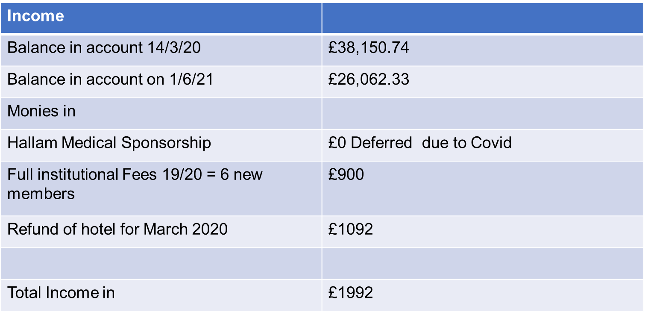

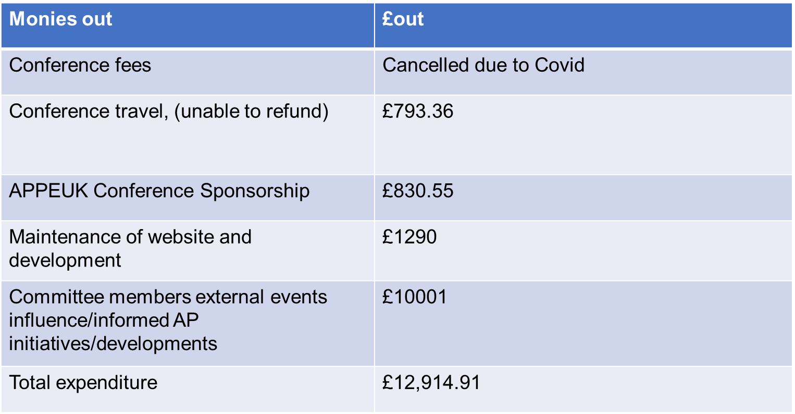

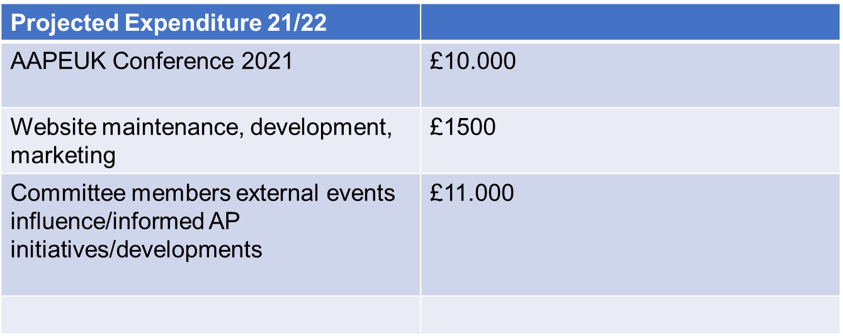

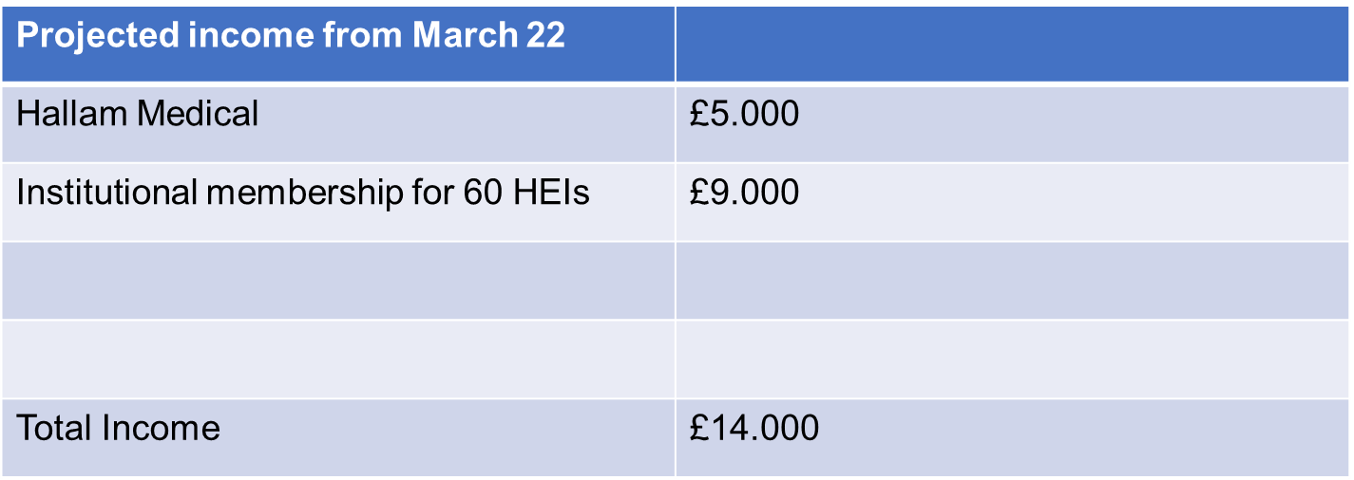

Action planning for 2021-2022

- Continue input into four country activities
- Promote membership AAPE UK to more Universities
- Promote membership AAPE UK to all Advanced Practice courses
- Continue work with Health Education England, Royal Pharmaceutical Society and the Council of Deans for Health
- Advanced Practice week November 2021
- Conference & AGM, Date to be confirmed for 2022

- Your suggestions?

Thank you and Closing Remarks

www.aape.org.uk @AAPEUK

Advanced Practice week - #ACPWeek20
7th- 13th November 2021

