The Association of Advanced Practice Educators (AAPE UK)
Annual General Meeting (AGM)

Friday 4th March 2016

Venue: University of Salford, The Old Fire Station Chambers

Time: 14.15
AGM Minutes

Welcome and Introductions
Chaired by Katrina Maclaine

Delegation list:
Amblum Jeshni | Guthrie Michael | O'Donnell Peter
Apau Daniel © | Haigh Kathryn© | Orton Helen
Bannister Mags | Harrison Lynne | Owens Suzanne
Barnett Donna | Harte Jacqui | Parker Nicola
Beach Steven | Hutchinson Mary | Pearce Ruth
Beaton Susan | Hodge Paula | Pennington Nicola
Brailsford Mandy | Hopkinson Clare | Phipps Ollie
Brownie Nicola | Inman Chris© | Powell Michelle
Coverdale Gill | Jeffery Paula | Price Ann
Cross Liz | Jenkins Jennifer | Price Jacky
Dalby Sara | Johnson Philip | Radford Mark
Duncan Rachel | Jones Anna© | Raioo Vijaya Naid
East Linda © | Jones Kate | Raleigh Mary
Edwards Rhiannon | James Kenney | Rees Ash
Edwards Mark © | Keinath Elke | Roberts Jane
First Sue | Lapworth Tracy | Samuriwo Ray
Frost Julia | Lupari Marina | Sibongi Sibanda
Gaskell Lynne | Maclaine Katrina© | Smith Liz
Gloster Annabella© | McElhinney Evelyn© | Snipe Dean
Green Diane | Measor Graham | Summerfield Neil
Griffith Heather | Mills Kerry | Sutcliffe Linda
Griffiths Beth | Munro Alex | Swift Juliette
Whittle Deborah | Nash Vicky | Tomlins Lucy
Windle Jill | Neary Anna© | Victor Elvina
 | Newson Annalisa | Walsgrove Hilary©
 | Newton Mel

- Approval of minutes of previous meeting
Approved – Kathy Haigh proposed and Daniel Apau seconded approval.

- Matters arising
Discussion around increasing the committee membership numbers to 16. The delegation agreed, and Kathy Haigh proposed whilst Linda East seconded the proposal, which was agreed.

AAPE UK are working on developing international links and are keen to construct a map of all international contacts. If any of the membership have any contacts that they can share, please contact the committee.

Please would you contact the committee if you have any suggestions for speakers for the next AAPE UK conference. Suggestions included:
- Including mental health practitioners
- Critical care practitioners
- Creation of YouTube channel to promote work

- Chair’s report
To include:
- Hallam Medical sponsorship
Thank you to Alex Munroe at Hallam Medical for sponsoring AAPE UK, enabling the committee to develop their work and website. Please see their website for further details.
- Website development – see above
- HEE work – Ruth Pearce (AAPE UK Chair) represents AAPE UK on steering group, and Katrina Maclaine represents AAPE UK on operational group, drawing on the work from all UK countries, which is ongoing. It was noted that £3 million has been allocated to develop Advanced Practice in Scotland.
The delegates were informed of the work undertaken by QNI, and Ruth Pearce has represented AAPE UK. Chris Oldman raised the issue of Safe staffing for community staff, and Anna Neary represents the APPE UK Committee.
- AHP representation – to increase the numbers of the committee to 16 to allow for AHP representation.
3 co-opted members now identified:
  - Helen Molton - orthoptist
  - Paula Jeffrey – paramedic/ nurse and
  - Kerry Mills - radiographer
2 new members welcomed to the committee:
  - Steven Beach, Kingston University and St. George’s, University of London
  - Claire Tubbritt, Coventry University

- Action planning for 2016-2017
Points taken from 2015-2016 action plan (please see website for action plan):
15.1 Katrina requested that any members who are involved in the development of advanced practice, should contact AAPE UK to share their experiences.

15.2 Hilary’s work on establishing an evidence base for effectiveness of advanced practice education is ongoing
15.3 Identify role of HEI in situations where practice issues arise which cause concern. Katrina to draft FAQ’s around governance and poor practice. To highlight NMC and HCPC similarities and differences.
15.4 Define new focus in terms of conference activity for AAPE UK committee members – funding provided for 2 members to attend ICN conference in Hong Kong, and Linda East is part of the ICN Education sub-committee.
15.5 – ICN International Conference attended by Katrina Maclaine and Annabella Gloster, increasing the international links that AAPE UK have. Linda East (Nottingham) is keen to develop survey to map links to overseas institutions. Please contact Linda East for further discussion/ suggestions.
15.6 Facilitate cross-course dialogue with staff and students – ongoing work by Chris Inman
15.7 Revise Constitution – revised last year to encompass AHP involvement. To be further revised this year, to increase membership.
15.8 To develop new AAPE UK website that is fit for purpose – has occurred but work is ongoing to further develop the site.
15.9 Explore funding opportunities through sponsorship from external companies to ensure longevity of AAPE UK and the development of a website that is fit for purpose- furthering links with Hallam Medical
15.10 Explore possibilities of website hosting an e-journal to encourage advanced practice students to publish their dissertations or other work - Journal for Community Nursing are considering developing an advanced practice supplement. Committee members and students are encouraged to contribute.

- Finance report – Hilary

With thanks to Alex at Hallam Medical for making possible the changes and developments within AAPE UK.

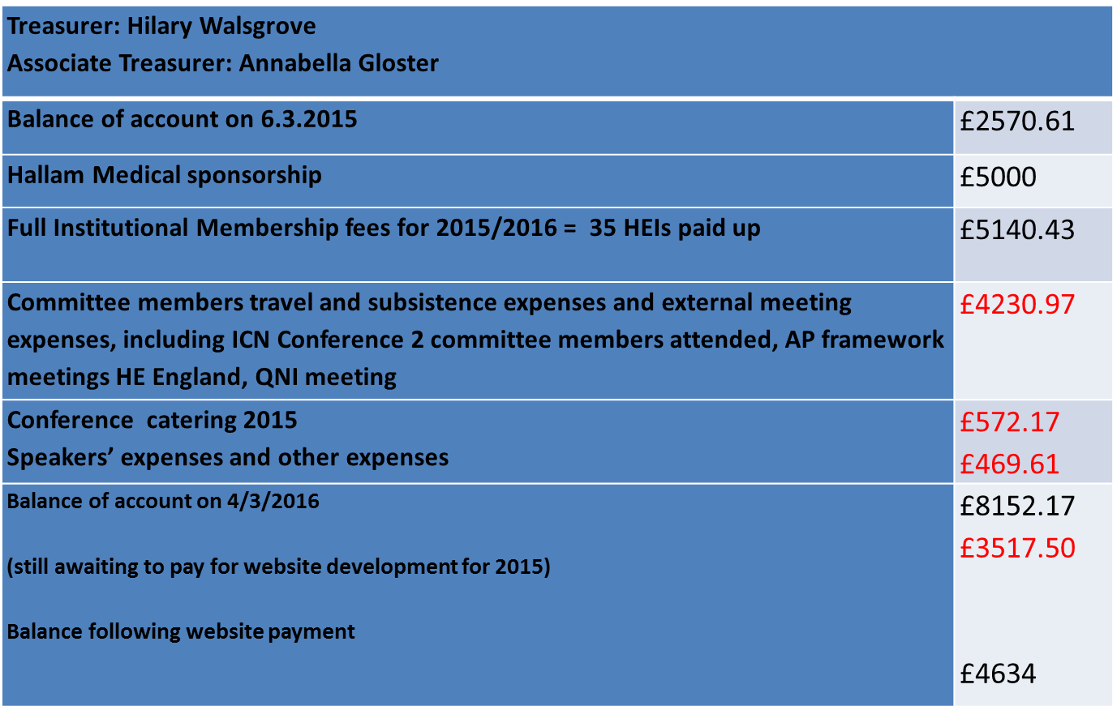

Projected expenditure for 2016:
Conference 2016  Conference speaker expenses and other expenses | £2000  £1000
Committee expenses  Committee attendance at external meetings, conferences to rep  represent AAPE UK | £4750
Support for membership to attend meetings, conferences etc. | £3000
Website maintenance and updates | To be confirmed
Projected income – Hallam Medical  Projected income from membership fees HEIs – x40 | 5000  6000

The number of HEI’s now listed as members of AAPE UK is almost 40.

- Elections
Proposal of committee roles and membership – agreed in opening speech, that constitution will be amended to include the 2 new full members, and that the 3 co-opted members will be invited to the next committee meeting

- Any other business:
- Future conference suggestions:
- PhD research presentations
- Pharmacist involvement as advanced practitioners and in supportive roles
- Education innovations
- Hearing from an advanced pharmacist re: their practice
- Focus on innovation in advanced practice education in supporting all the 4 pillars to include distance learning and blended learning and clinical practice education support

- Date and time of next meeting:

AGM March 2017– 3rd March 2017 time approx.: 9-4pm

Venue Bristol - TBC

(Committee Meeting – 6th May 2016)

