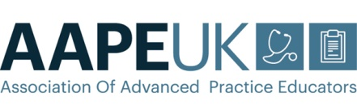

The Association of Advanced Practice Educators (AAPE UK)
Minutes of the Committee Meeting held on Friday 29th January 2021
Virtual platform: Microsoft Teams
10am start

- Welcome:
KH welcomed those present to the meeting. The committee members introduced themselves to VM who has joined the group as a co-opted member as lead for the ACP apprenticeship EPA working group. KH notified the committee of resignations from Daniel Monk and Martin Galligan due to the challenges of time commitment for AAPE activities. Their input to previous meeting discussions was acknowledged.

- Present:
Kathy Haigh  (Chair) | KH | University of Cumbria | Kathryn.haigh@cumbria.ac.uk
Anna Jones  (Deputy Chair) | AJ | Cardiff University | Jonesa23@cf.ac.uk.
Anna Neary  (Treasurer) | AN | University of Western England | Anna2.Neary@uwe.ac.uk
Deborah Slade  (Secretary) | DS | Oxford Brookes University | daslade@brookes.ac.uk
Helen Rushforth | HR | Southampton University | her@soton.ac.uk
Collette Henderson | CH | University of Dundee | c.m.j.henderson@dundee.ac.uk
Diane Reid | DR | Manchester Metropolitan University | diane.reid4@nhs.net
Katrina Maclaine | KMc | London South Bank University | maclaik@lsbu.ac.uk
Donna McConnell | DMc | Ulster University | d.mcconnell@ulster.ac.uk
Chris Inman | CI | Birmingham City University | Chris.inman@bcu.ac.uk
Vicky Macarthur  (Co-opted member) | VM | Oxford Brookes University | vmacarthur@brookes.ac.uk

Apologies:
Helen Orton | HO | University of Liverpool | h.p.orton@liverpool.ac.uk
Pippa Clark | PC | Midwife / Neonates Advisor | Pippa.Clark@fhft.nhs.uk
Kerry Mills | KM | Radiographer Advisor | Kerry.Mills@uwe.ac.uk
Hilary Walsgrove | HW | Bournemouth University | hwalsgrove@bournemouth.ac.uk

Advisor (not in attendance):
Rob Harvey | RH | Pharmacist Advisor | rharvey@bournemouth.ac.uk
- Approval of minutes from previous meetings:
- Minutes from the 27th November were amended to reflect an accurate record of the meeting.
Action: AJ to upload document to the website

- Matters arising from the minutes/ actions points:
- These were included in the agenda for the meeting.

- Chair’s report:
- KH confirmed the postponement of the annual conference from March 19th to June 25th due to ongoing pressures of the pandemic on healthcare services staff. It was proposed that future conferences would also be scheduled in June / midyear. (see point 11)
- HEE ACP National Operation Group – KH said there was no update
- HEE ACP National Steering Group – KMc said there was no update, but she would email the group re: information on the work streams that exist outside the ‘Centre for Advancing Practice’.
- HR shared the following slide denoting the HEE structure…

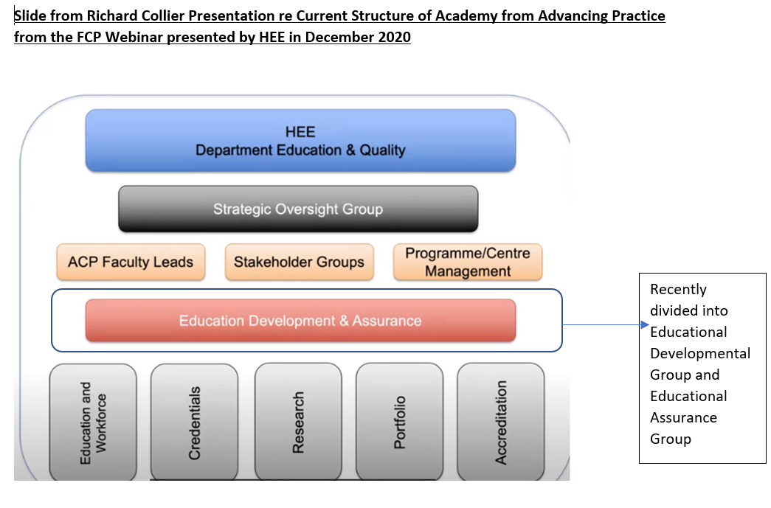

With the Education Development and Assurance Group now functioning as two separate groups KMc highlighted that as an ‘external critical friend’ AAPE should have representation on the Assurance Group.
- HEE Programme accreditation – KMc and HR, as part of the HEE Education Group, said issues on transparency of accreditation processes had been raised because it appeared that limited resources were impacting on HEIs submitting their documents. KH questioned the quality assurance of such processes. Currently, application slots for accreditation are available up to December 2021.
- HEE work streams:
  - End of Life / Palliative Care - core credentials will be completed and out for consultation soon.
  - First Contact Practitioner – programme outline will be out for tender very soon.
  - ACP Mental Health (MH) Standards – KMc said LSBU is one of five early adopter sites (assumes readiness) who will contribute information to an external review. It is apparent that external placements are needed to facilitate the physical health / biomedical aspects of the programme.
  - Paediatrics, in collaboration with RCPCH, are planning children’s and neonatal programme routes – no further update at present.
- The AP Midwifery scoping project undertaken by the UEA should be published soon.
  - It is understood HEE will then work on a Midwifery specific AP Framework.
- HEE Advanced Practice Regional Faculty Leads – all positions have been appointed.
- HEE Regional Faculty Supervision Leads – almost all positions filled ?invite to the conference
- Royal Pharmaceutical Society – developing an advanced pharmacist credentialing process to bridge the gap between the RPS Newly Qualified curriculum (due early 2021) and the RPS Consultant Pharmacist curriculum. AAPE will be represented on the Advanced Pharmacist Programme Core Curriculum group by CH and on the Advanced Pharmacist Programme Core Assessment group by DS.
- KH has reviewed a text book for which she received a £100 book token – this will be used as a prize in the June 25th conference poster presentation competition

- Committee membership, roles and responsibilities:
- Vicky Macarthur (Lead for apprenticeship EPA) joined the committee as a co-opted member
- AN gave notice of her intention to step down as Treasurer in one year’s time – committee members were asked to consider whether they are interested in taking on this role

- Country updates:

Scotland
Update from CH:
- Awaiting publication of CNS paper
- Adults with incapacity (AWI) – work continues in order to disseminate to HEIs
- HEI Leads Group are developing an ‘Advanced Practice Network’ to improve links
- The Remote and Rural Capabilities Framework is to be launched in March. Discussion with HW is needed on the independent portfolio route.
- The Advanced Practice Academies / Regional Health Board Areas – work is ongoing to produce an ‘advanced practice newsletter’ to optimise communication.

Wales
Update from AJ:
- The impact of the pandemic on healthcare services predominates
- The All Wales AP Network inaugural meeting has taken place and subsequent meetings are planned to continue the process of building links

Northern Ireland
Update from DMc
- The impact of the pandemic on healthcare services predominates
- Links have been made with leads for Galway advanced practice courses

England
Update from KH
- See point 5 - Chair’s Report.

- Membership:

- AN – AAPE UK total membership = 58 HEIs out of a total 88 who deliver ACP education. The committee were asked to contact local HEIs who are not members (highlighted) to promote the benefits of joining AAPE UK:
Action: KH to draft an email message for committee members to send to HEIs

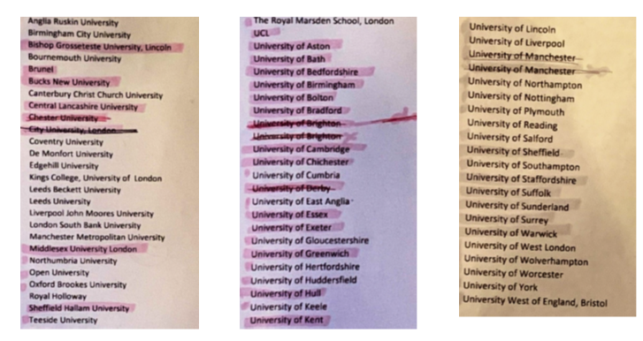

- Finance report:

HEE | IN | OUT | Balance
Project Money | £40,000 | £20,767.04 | £19,232.96
Project 1 | £20,000 | £10,291.50 | £9,708
Project 2 | £20,000 | £10,475.54 | £9,524.46
Free membership 1 year 20/21 52 universities |  | £7,800 | £13,049.46
Agreed sponsorship for ICN conference |  | £1,500 | £11,549.46

Membership Money
52 University members | £0
New membership x5 | £750
Hallam Sponsorship | Invoiced
Hotel refund | £1,092
Account Balance | £31,985.38
Project Balance | £19,232.96
Balance minus project monies | £12,752.42

- Due to the positive balance in the association’s account it was decided:
  - newly recruited HEIs should be offered a free year’s membership
  - current HEI members should be offered another year’s free membership
  - Hallam Medical - sponsorship fees should be waived?
Action: AN and KH to instigate final arrangements
- Scholarships:
- Three committee members are planning to attend the online September 2021 ICN NP/APN conference, and will be applying for AAPE UK Scholarship funding.

- Conference:
- use of external company to facilitate an online conference, AJ talked through the scope of services provided by the four company quotes below:
- Grapevine Events: £7750 +VAT
- AOTV: £7440 (inc. VAT)
- Production 76: (if you can find it, buried in the marketing info): £9,906.00 (inc. VAT)
- ATTOLO: £15,500 +VAT
- AOTV was considered a good option as the company is known to AJ / Cardiff University
- In preparation for the conference:
- Speakers are to be informed, and availability for the 25th June established - KH
- KH will email the membership
- AJ to update information on the website

- HEE ACP Project Work
- HW was not present so no new updates were shared.

- Advanced Practice Apprenticeship
- VM provided feedback from the ACP Apprenticeship workshop on Thursday 26th Nov:
  - 28 HEIs were represented at the workshop
Activities so far include:
  - Building a ‘Question Bank’ – 24 questions for a three year period. The external assessor will choose the questions to assess each student. Plan to ‘sign off’ the ‘Question Bank’ at the meeting on 1st February.
  - Designing a rubric(s) for the exam
  - Developing the format for example case studies – to test questions
  - HW has developed a form for individuals wanting to register as an independent assessor
  - Developing an ‘online package’ for training / updating external assessors for EPA – discussions ensued as to whether AAPE should propose the format / content of the package from a generic perspective with specific detail the responsibility of the HEI employing the external assessor - VM

- Advanced Practice Week:
- 8th – 14th November 2021

- Website
- AJ proposed having country specific areas on the website
  - General Open Area would include information / updates on all four countries
  - Specific details relevant to practitioners working in Scotland, Northern Ireland, and Wales would be in a members only area with password protected access

- Social Media
- KH, DR and CH are ‘Twitters’ for AAPE UK

- International Networking and International Affiliate Membership
- RP, CH and AN will be attending the online ICN Conference in September 2021. Use of the ‘Scholarship funding’ requires inclusion of AAPE UK logo on any submitted presentations - these will then be uploaded to the website after the conference.

- Action Plan
To be updated Action: DS and KH

- Elections:
- KH to resend email inviting nominations to join the committee
- DMc sought confirmation there are five ‘spaces’ on the committee due to recent resignations

- Any other business:
CI – highlighted that the AP Forum / ICN have a new definition for AP nurse development proposed by the European Federation of Nursing, which is similar to the four pillars structure
AN – highlighted that the ICN Policy Group are producing methodologies for training. AN also raised the issue of diversity, and that this should be considered when inviting new members to the committee
Action: KH - add to election materials and discuss as agenda item at next meeting

Date of the next meeting:
- Friday 19th March 2021

